**­05/11/2021**

**Pandemic Preparedness and the H1N1 Pandemic**

**Swine Flu Data:** a challenge to find! WHO datasets seem to have been lost:

* <https://www.kaggle.com/imdevskp/h1n1-swine-flu-2009-pandemic-dataset> 04/04/2009 – 06/07/2009.
* Pandemic lasted from 01/2009 to 08/2010; but countries were no longer required to test and report individual cases after 06/07/2009.
  + Data was scraped from the WHO website.

Raw data reported cumulative cases and deaths on various days in the date range, for a given country, so I started by generating the maximum cumulative cases value for each country:

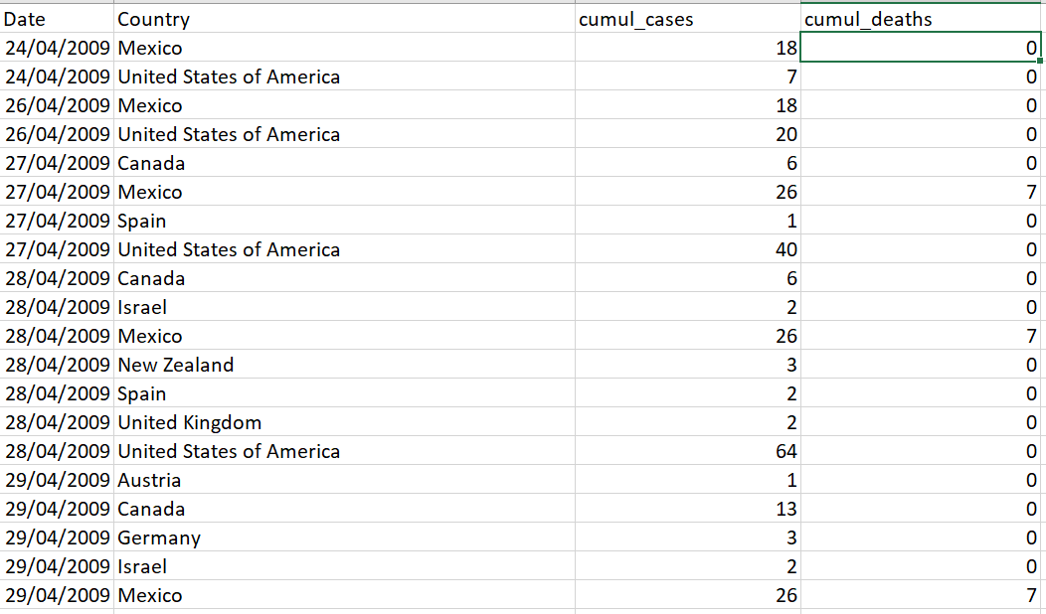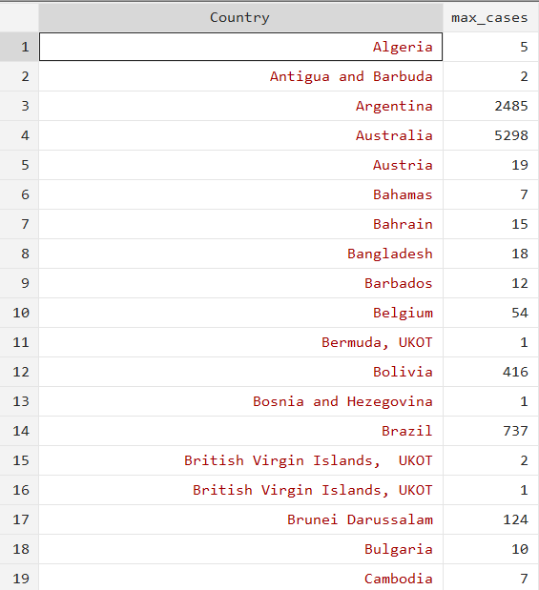

I then merged this with the X Variable data, yielding:

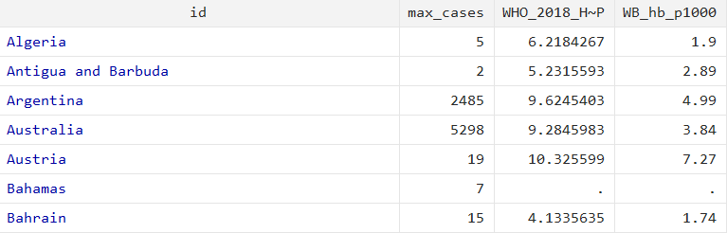

**Scatterplots**

Important note: I’ve dropped USA data in the scatterplots, since it has an extremely high value (33902 cases). Clearly not a trivial omission, but for now it makes the graphs a lot clearer.





**Takeaways:**

* Distribution of cases is skewed right (here’s a disproportionate amount of countries with very few cases)
* Perhaps hard to infer much else!

**Regression Results**

**Max Cases and Hospital Beds**

**Linear regression**

|  |  |  |  |  |  |  |  |  |  |  |  |
| --- | --- | --- | --- | --- | --- | --- | --- | --- | --- | --- | --- |
| WB_hb_p1000 | Coef. | | St.Err. | t-value | | p-value | [95% Conf | | Interval] | | Sig |
| max_cases | -.00008 | | .00008 | -1.06 | | .2921 | -.00023 | | .00007 | |  |
| Constant | 3.20624 | | .24551 | 13.06 | | 0 | 2.7191 | | 3.69337 | | *** |
|  | | | | | | | | | | | |
| Mean dependent var | | 3.15816 | | | SD dependent var | | | 2.36027 | |
| R-squared | | 0.00354 | | | Number of obs | | | 101.00000 | |
| F-test | | 1.12186 | | | Prob > F | | | 0.29210 | |
| Akaike crit. (AIC) | | 462.73431 | | | Bayesian crit. (BIC) | | | 467.96455 | |
| *\*\*\* p<.01, ** p<.05, * p<.1* | | | | | | | | | | | |
|  | | | | | | | | | | | |

**Max Cases and Health Expenditure**

**Linear regression**

|  |  |  |  |  |  |  |  |  |  |  |  |
| --- | --- | --- | --- | --- | --- | --- | --- | --- | --- | --- | --- |
| WHO_2018_HE_GDP | Coef. | | St.Err. | t-value | | p-value | [95% Conf | | Interval] | | Sig |
| max_cases | .00026 | | .00015 | 1.69 | | .09435 | -.00005 | | .00057 | | * |
| Constant | 6.70515 | | .25864 | 25.92 | | 0 | 6.19181 | | 7.21849 | | *** |
|  | | | | | | | | | | | |
| Mean dependent var | | 6.86226 | | | SD dependent var | | | 2.45021 | |
| R-squared | | 0.03438 | | | Number of obs | | | 99.00000 | |
| F-test | | 2.85421 | | | Prob > F | | | 0.09435 | |
| Akaike crit. (AIC) | | 457.92304 | | | Bayesian crit. (BIC) | | | 463.11328 | |
| *\*\*\* p<.01, ** p<.05, * p<.1* | | | | | | | | | | | |
|  | | | | | | | | | | | |

**Next Steps/Thoughts**

The data seems limited: hard to tell if the effects of H1N1 were actually very concentrated, or if during this period they were concentrated.

Need to control for GDP: no time this week!

Also want to look into the effect on the rate of increase of hospital beds/health expenditure, to isolate the causal mechanism more.

**Todo:**

Generate time series graphs of hospital beds and health expenditure. Look at the data to decide when to start the time series.

Control for GDP/capita

Regress hospital bed/health expenditure rate of increase from 2010-2012 on cases.